**# Chicago Crimes**

Crimes and violence is something that worries the entire world.

From 2016 to 2017 Chicago was one of the top 20 dangerous cities in US

This analysis was created in order to understand:

- Which were the years with more crimes in last 10 years?

- What are the communities with more crimes in last years?

- What are the most common types of crimes?

- Which is the relation between crimes per community and arrested criminals?

**Crimes per Year**

Crimes per community

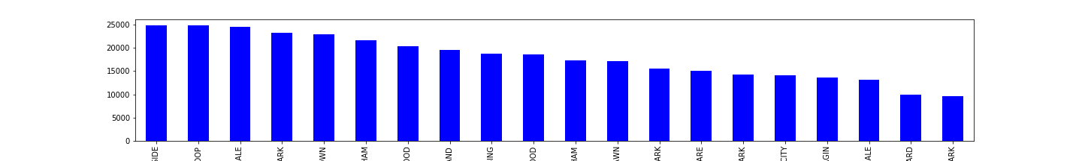

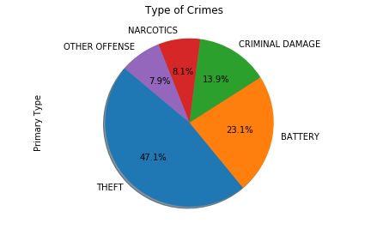

**Crimes per Location**

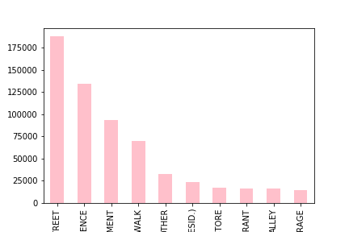

**Top 5 Communities with crimes and arrested**

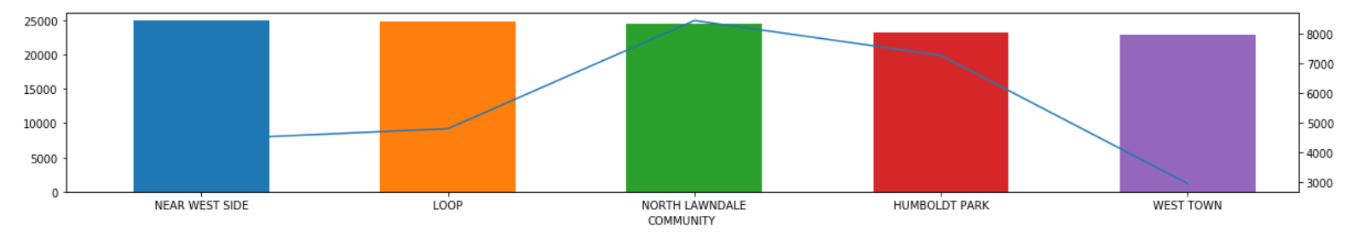

**Top 5 Communities with less crimes and arrested**

